BMC simulator setup and operation

# Setup

BMC simulator link:

<https://github.schneider-electric.com/SESA480732/BMC-simulator>

run git clone <https://github.schneider-electric.com/SESA480732/BMC-simulator> to get the latest simulator

use python 3.5 to run the simulator

# Operation

Run the simulator:

python BmcUi.py

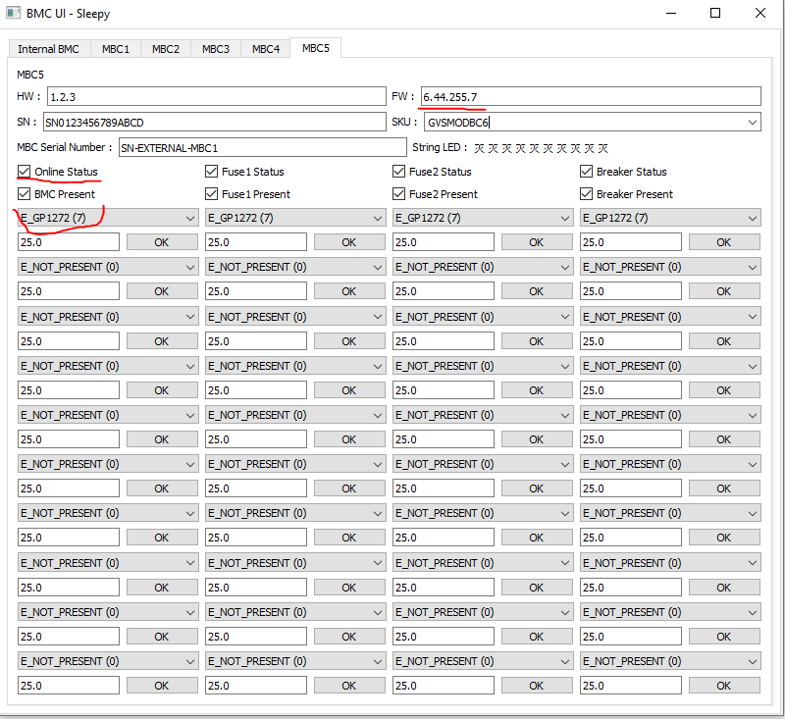

Note point

1. FW version should be updated same as the UPS version or XX.XX.255.XX
2. Type of the cartridge should be selected
3. Online status should be checked

Then BMC simulator is run

# Configuration

1. Tuner should set battery solution as modular battery
2. MBC Quantity should be set if external MBC will be simulated